

PROJECT REPORT

**ON**

**STOCK MARKET PREDICTION SYSTEM**

**SUBMITTED**

**TO**

**ROURKELA INSTITUTE OF MANAGEMENT STUDIES**

(As a partial fulfilment of the requirement for the award of Degree)

**FOR**

**MASTER IN COMPUTER APPLICATION**

**SUBMITTED BY**

**SUBHENDU BISWAL**

**REGD NO: 2205260027**

**MCA 4 TH SEMESTER (2022-2024)**

**ROURKELA INSTITUTE OF MANAGEMENT STUDIES**

(Affiliated to Biju Patnaik University of Technology)



**Rourkela Institute of Management Studies**

Rourkela

Department of Computer Science

Rourkela Institute of Management Studies

Chhend, Rourkela-15, Odisha

Phone:0661 2480482

Fax: 91-0661-1480665

Visit: [www.rims-edu.com](http://www.rims-edu.com)

**CERTIFICATE OF EXAMINATION**

This is to certify that this project report entitled **“STOCK MARKET**

**PREDICATION”** submitted by **SUBHENDU BISWAL** of 4th semester, **Rourkela Institute of Management Studies, Rourkela,** is accepted as partial fulfilment of requirements for the degree in Master In Computer Applications, under **Biju Patnaik University of Technology, Rourkela** this has been verified by us and

found to be original up to our satisfaction.

**Examiner**



**Rourkela Institute of Management Studies**

Rourkela

Department of Computer Science

Rourkela Institute of Management Studies

Chhend, Rourkela-15, Odisha

Phone:0661 2480482

Fax:91-0661-1480665

Mail: rkl_rimsgrol@sancharnet.in

Visit: [www.rims-edu.com](http://www.rims-edu.com)

**CERTIFICATE**

This is to certify that this project entitled **“STOCK MARKET PREDICTION SYSTEM”** has been and submitted by **SUBHENDU BISWAL,** M.C.A 2022-2024, **Rourkela Institute of Management Studies, Rourkela,** has been examined by us. He is found fit and approved for the award of **“Master in Computer Application “**Degree.

To the best my knowledge this work has not been submitted for the award of any other degree.

I wish all the success in his life.

DEAN ACADEMICRIMS, ROURKELA



Prof. Bibhudendu Panda Head of The

Department, MCA

Rourkela Institute of Management Studies, Rourkela

**CERTIFICATE**

This is to certify that **SUBHENDU BISWAL** student of **M.C.A, Rourkela Institute of Management Studies, Rourkela, Odisha** of Session 2022-2024 has completed the project successfully.

I wish all success in his life

**(Prof. Bibhudendu Panda)**



**DECLARATION**

I, **SUBHENDU BISWAL**, hereby declare that the project report

entitled “**STOCK MARKET PREDICTION SYSTEM**” is my work. The above work I submitted to “**Biju Patnaik University of Technology, Rourkela '' for** the award of **“Master in Computer Applications**” Degree.

To the best of my knowledge, this work has not been submitted or

published anywhere for the award of any degree.

**SUBHENDU BISWAL**



**ACKNOWLEDGEMENT**

I am deeply indebted to **Rourkela Institute of Management Studies, Chhend,**

**Rourkela,** for providing me an opportunity to undertake a project work entitled **“STOCK MARKET PREDICTION SYSTEM”.**

I am grateful to my project guide **Prof. Bibhudendu Panda and prof. Damodar Nayak** without his guidance it would not have been possible on my part to complete the project.

I acknowledge the help and co-operation received from all my team members in making this project.

I consider myself fortunate that I have successfully completed this project; I

acknowledge my sincere gratitude to all those works and ideas that had helped me in writing

this project.

*SUBHENDU BISWAL*

**University Roll No: 2205260027**

**MCA (2022-2024)**

**Rourkela Institute of Management Studies,**

**Rourkela.**

**ABSTRACT**

It has never been easy to invest in a set of assets, the abnormality of the financial market does not allow simple models to predict future asset values with higher accuracy. Machine learning, which consists of making computers perform tasks that normally require human intelligence is currently the dominant trend in scientific research. This article aims to build a model using

Machine learning Model using Deep Learning especially Long-Short Term Memory model (LSTM) to predict future stock market values. The main objective of this paper is to see in which precision a Machine learning algorithm can predict. Predicting stock market prices is a complex task that traditionally involves extensive human-computer interaction. This will provide more

accurate results when compared to existing stock price prediction algorithms. The network is trained and evaluated for accuracy with various sizes of data, and the results are tabulated. This paper is to predict stock market prices to make more acquainted and precise investment decisions.

# CONTENT

**SERIAL NO CHAPTER PAGE NO.**

**1 Introduction 9-11**

**2 Methodology 12-16**

**3 Tools Selection 17-18**

**4 Data collection setup 19-20**

**5 Data preprocessing 21-22**

**6 Model development initiation 23-24**

**7 Model Training 25-26**

**8 Model evaluation 27-28**

**9 Visualization setups 29-30**

**10 Web application integration 31-32**

**11 source code 33-42**

**12 Different stocks analysis and report 43-54**

**13 conclusion 55-56**

# CHAPTER 1

**Introduction**

**1.1 Preface**

• Stock Market Prediction is the act of trying to determine the future values of Company Stock or other.

• Stock Market Prediction is basically defined as trying to determine the stock value and offer a robust idea for the people to know and predict the market and the stock prices, it is generally Presented using the quarterly financial Ratio using the Data set.

• The use of Machine Learning and Artificial Intelligence techniques to predict the Prices of the Stock is an increasing trend.

**1.2 Understanding the Problem Statement**

We’ll dive into the implementation part of this Project soon, but first it’s important to establish what we’re aiming to solve. Broadly, stock market analysis is divided into two parts –Fundamental Analysis and Technical Analysis.

● Fundamental Analysis involves analysing the company’s future profitability on the basis of its current business environment and financial performance.

● Technical Analysis, on the other hand, includes reading the charts and using statistical figures to identify the trends in the stock market. As you might have guessed, our focus will be on the technical analysis and visualization part. We’ll be using a dataset from Google stock Price test and train.

**1.3 Motivation for Work**

Businesses primarily run over customer’s satisfaction, customer reviews about their products. Shifts in sentiment on social media have been shown to correlate with shifts in stock markets. Identifying customer grievances thereby resolving them leads to customer satisfaction as well as trustworthiness of an organization. Hence there is a necessity of an unbiased automated system to classify customer reviews regarding any problem. In today’s environment where we’re justifiably suffering from data overload (although this does not mean better or deeper insights), companies might have mountains of customer feedback collected; but for mere humans, it’s still impossible to analyse it manually without any sort of error or bias. Oftentimes, companies with the best intentions find themselves in an insights vacuum. You know you need insights to inform your decision making and you know that you’re lacking them, but don’t know how best to get them. Sentiment analysis provides some answers into what the most important issues are, from the perspective of customers, at least. Because sentiment analysis can be automated, decisions can be made based on a significant amount of data rather than plain intuition.

**1.3 Project Overview**

Stock (also known as equity) is a security that represents the ownership of a fraction of a corporation. This entitles the owner of the stock to a proportion of the corporation's assets and profits equal to how much stock they own. Units of stock are called "shares."

A stock is a general term used to describe the ownership certificates of any company.

Stock prices change every day by market forces. By this we mean that share prices change because of supply and demand. If more people want to buy a stock (demand) than sell it (supply), then the price moves up.

Conversely, if more people wanted to sell a stock than buy it, there would be greater supply than demand, and the price would fall.

Understanding supply and demand is easy. What is difficult to comprehend is what makes people like a particular stock and dislike another stock. This comes down to figuring out what news is positive for a company and what news is negative. There are many answers to this problem and just about any investor you ask has their own ideas and strategies.

That being said, the principal theory is that the price movement of a stock indicates what investors feel a company is worth. Don't equate a company's value with the stock price. The value of a company is its market capitalization, which is the stock price multiplied by the number of shares outstanding. For example, a company that trades at $100 per share and has 1,000,000 shares outstanding has a lesser value than a company that trades at $50 but has 5,000,000 shares outstanding ($100 x 1,000,000 = $100,000,000 while $50 x 5,000,000 = $250,000,000). To further complicate things, the price of a stock doesn't only reflect a company's current value–it also reflects the growth that investors expect in the future.

So, why do stock prices change? The best answer is that nobody really knows for sure. Some believe that it isn't possible to predict how stocks will change in price while others think that by drawing charts and looking at past price movements, you can determine when to buy and sell. The only thing we do know as a certainty is that stocks are volatile and can change in price extremely rapidly.

**1.4 Purpose**

The title of our project is Stock Market Prediction, it is an online model to predict the stock prices of company. This project concerned about developing an online model that will be used for investors to invest smartly.

The stock market is basically an aggregation of various Predicting the Stock Market has been the bane and goal of investors since its existence.

Everyday billions of dollars are traded on the exchange, and behind each dollar is an investor hoping to profit in one way or another.

It is no wonder then that the Stock Market and its associated challenges find their way into the public imagination every time it misbehaves.

The 2008 financial crisis was no different, as evidenced by the flood of films and documentaries based on the crash.

If there was a common theme among those productions, it was that few people knew how the market worked or reacted.

A stock (also known as shares more commonly) in general represents ownership claims on business by a particular individual or a group of people. To determine the future value of the stock market is known as a stock market prediction. The prediction is expected to be robust, accurate and efficient. The system must work according to the real-life scenarios and should be well suited to real.

**1.5 Project Scope**

The goal of this project is to predict a stock price of a company according to its previous historical data. Stock Market Prediction is composed of main com- ponents: a company’s historical data of stock which will help to analyses the current and previous changes of stock price. The above proposed model is easy to implement considering the available technology infrastructure. The model is simple, secure and scalable. The proposed model is based on serial communication. These models will help the investors to invest their money according to the predicted value, investor’s may have less chances of loss and a very huge chance of making more profit.

**1.6 objective**

Objective setting is a crucial aspect of any project, laying the foundation for its direction, purpose, and desired outcomes. In the context of the Stock Market Prediction System project, objective setting involved defining clear and measurable goals aimed at developing a robust system for predicting future stock prices accurately. The primary objective was to empower investors, traders, and financial analysts with valuable insights derived from historical market data, enabling them to make informed decisions and mitigate investment risks. This involved identifying the target audience, understanding their needs and challenges, and establishing the significance of reliable predictions in navigating the dynamic stock market environment. By setting specific objectives, such as achieving high prediction accuracy, ensuring system reliability, and creating a user-friendly interface, the project aimed to address key requirements and deliver tangible benefits to users. Additionally, ethical considerations were integrated into the objective setting process to ensure responsible use and deployment of the prediction system, aligning with principles of transparency, fairness, and data privacy. Overall, objective setting provided a roadmap for guiding the project's development and shaping its outcomes to meet the needs of stakeholders effectively.

# Chapter 2

**Methodology**

**In this chapter, we outline the detailed methodology employed in the development of the Stock Market Prediction System. The methodology encompasses various stages, from data collection to model evaluation and deployment. Each step is meticulously designed to ensure the accuracy, reliability, and effectiveness of the prediction system. Below, we provide a comprehensive overview of the methodology followed in this project:**

**2.1 Data Collection:**

- Utilize the yfinance library to programmatically fetch historical stock market data from Yahoo Finance.

- Specify the desired stocks and time period for data retrieval to ensure relevance and completeness.

- Store the collected data in a structured format for further analysis and processing.

**2.2 Data Preprocessing:**

- Clean the collected data to address any issues such as missing values, outliers, or inconsistencies that may affect the quality of analysis.

- Handle missing values by imputation or removal based on the specific context and impact on the dataset.

- Normalize the data to ensure consistency and comparability across different features and stocks.

- Perform feature engineering to create additional relevant features such as moving averages, relative strength index (RSI), and technical indicators to enhance predictive performance.

**2.3 Splitting Data for Training and Testing:**

- Divide the pre-processed dataset into two subsets: one for training the models and the other for testing their performance.

- Allocate 80% of the data for training to allow the models to learn patterns and relationships in the historical data.

- Reserve 20% of the data for testing to evaluate the trained models' performance on unseen data and assess their generalization ability.

**2.4 Algorithm Selection:**

- Choose appropriate algorithms for the prediction task, considering factors such as data characteristics, model complexity, and computational efficiency.

- Select the K-Nearest Neighbours (KNN) algorithm for establishing a baseline comparison due to its simplicity and intuitive nature.

- Opt for the Long Short-Term Memory (LSTM) model as the primary predictive model, leveraging its ability to capture long-term dependencies and sequential patterns in time series data effectively.

**2.5 Neural Network Development:**

- Implement the LSTM model using TensorFlow, a powerful and flexible deep learning framework.

- Define the architecture of the LSTM network, including the number of layers, units, activation functions, and input/output dimensions.

- Train the LSTM model on the training data using appropriate optimization techniques such as stochastic gradient descent (SGD) or Adam optimizer to minimize the prediction error.

**2.6 Model Evaluation:**

- Evaluate the performance of the trained models using established metrics such as Mean Absolute Error (MAE), Mean Squared Error (MSE), and Root Mean Squared Error (RMSE).

- Compare the predicted stock prices against the actual values from the testing set to assess the accuracy and reliability of the models.

- Analyze additional performance metrics such as precision, recall, and F1-score to gain deeper insights into the models' strengths and weaknesses.

**2.7 Web Application Development:**

- Develop an interactive web application using Streamlit, a Python library for building data-driven web applications.

- Integrate the trained models into the web application to provide users with a seamless and intuitive interface for accessing stock predictions and visualizing results.

- Incorporate interactive features such as input forms, dropdown menus, and interactive charts to enhance user engagement and usability.

**2.8 Deployment and Iteration:**

- Deploy the prediction system to a suitable hosting environment, ensuring scalability, reliability, and security.

- Monitor the system's performance in real-world usage, collecting user feedback and monitoring key performance indicators (KPIs) to identify areas for improvement.

- Iteratively refine the prediction system based on user feedback, performance metrics, and emerging market trends to enhance its effectiveness and adaptability over time.

**2.9 Flow chart:**

**Start**

**|**

**|--- Data Collection**

**| |**

**| |--- Gather historical stock market data from Yahoo Finance**

**| |**

**| |--- Clean the raw data to address inconsistencies and errors**

**| |**

**| |--- Validate and preprocess the cleaned data**

**| |**

**| |--- Store the preprocessed data for model development**

**|**

**|--- Model Development**

**| |**

**| |--- Select appropriate predictive models (e.g., LSTM)**

**| |**

**| |--- Prepare the data for model training**

**| |**

**| |--- Configure the model architecture and hyperparameters**

**| |**

**| |--- Train the model using the prepared data**

**| |**

**| |--- Evaluate the trained model's performance**

**| |**

**| |--- Fine-tune the model for optimization (optional)**

**|**

**|--- Visualization Setup**

**| |**

**| |--- Select visualization tools (e.g., Matplotlib, Streamlit)**

**| |**

**| |--- Install and configure the chosen visualization libraries**

**| |**

**| |--- Design and create visualizations for model outputs**

**| |**

**| |--- Integrate visualizations into the web application**

**|**

**|--- Web Application Integration**

**| |**

**| |--- Choose a web framework (e.g., Streamlit)**

**| |**

**| |--- Develop the web application interface**

**| |**

**| |--- Integrate predictive models and visualizations into the application**

**| |**

**| |--- Implement interactive features and controls**

**| |**

**| |--- Test the web application for functionality and usability**

**|**

**|--- Documentation and Reporting**

**| |**

**| |--- Document the entire project process, including data collection, model development, visualization setup, and web application integration**

**| |**

**| |--- Create user guides, technical documentation, and project reports**

**| |**

**| |--- Share the documentation with stakeholders and team members**

**|**

**End**

---

**This chapter provides a structured overview of the methodology employed in developing the Stock Market Prediction System, guiding the project from data collection to deployment and iteration. Each step is essential for ensuring the success of the prediction system and delivering valuable insights to users.**

# **Chapter 3**

**Tools selection**

**In this chapter, we delve into the selection process of tools and technologies that underpin the development of the Stock Market Prediction System. Each tool was meticulously chosen based on its capabilities, suitability for specific tasks, and contribution to achieving the project's overarching objectives. Below, we provide an in-depth exploration of the tools utilized:**

**3.1 TensorFlow:**

- TensorFlow emerged as the cornerstone of our project, serving as the primary deep learning framework for constructing and training neural network models. Renowned for its flexibility, scalability, and extensive ecosystem, TensorFlow provides a rich suite of tools and libraries for implementing complex machine learning architectures. Specifically, we leverage TensorFlow's high-level APIs to design and train sophisticated models such as Long Short-Term Memory (LSTM) networks, which are well-suited for capturing temporal dependencies in time series data.

**3.2 yfinance:**

- For procuring historical stock market data, we turned to the yfinance library. This lightweight and user-friendly Python package seamlessly integrates with Yahoo Finance, enabling us to effortlessly retrieve comprehensive datasets for a wide range of stocks. With yfinance, we can specify specific stocks and time intervals, ensuring the acquisition of relevant and up-to-date financial data crucial for our analysis and model training.

**3.3 Matplotlib:**

- Data visualization plays a pivotal role in conveying insights and trends derived from stock market data. Matplotlib emerged as our visualization tool of choice, offering a comprehensive suite of plotting functions and customization options. With Matplotlib, we can generate a diverse range of charts and graphs, including line plots, scatter plots, and histograms, allowing us to effectively visualize historical stock data, predicted prices, and model performance metrics. Its seamless integration with Python makes it an indispensable tool for crafting informative and visually appealing visualizations.

**3.4 NumPy:**

- NumPy serves as the backbone for numerical computing and data manipulation tasks within our project. Its powerful array-based operations and mathematical functions facilitate efficient handling of structured data, particularly in the preprocessing and feature engineering stages. With NumPy, we can perform array operations, mathematical computations, and statistical analyses with ease, ensuring the integrity and consistency of our data throughout the model development process.

**3.5 Pandas:**

- Pandas emerges as a pivotal tool for data manipulation and analysis, providing powerful data structures and functions tailored for structured data. Leveraging Pandas, we can efficiently clean, transform, and aggregate stock market data, addressing challenges such as missing values, outliers, and data inconsistencies. Its intuitive and user-friendly interface streamlines the data manipulation process, empowering us to preprocess the data effectively before feeding it into our machine learning models.

**3.6 Streamlit:**

- As we seek to democratize access to stock market predictions, an intuitive and user-friendly interface is paramount. Streamlit, a Python library for building interactive web applications, emerged as the ideal solution for developing our prediction system's front-end. With Streamlit, we can rapidly prototype and deploy interactive dashboards and applications, enabling users to input stock symbols, visualize historical data, obtain predictions, and assess model performance effortlessly. Its simplicity and ease of use make it an invaluable tool for enhancing user engagement and accessibility.

**3.7 Integrated Development Environment (IDE):**

- An Integrated Development Environment (IDE) serves as the nerve center of our development workflow, providing a conducive environment for code development, debugging, and experimentation. Whether utilizing PyCharm or Jupyter Notebook, these IDEs offer essential features such as syntax highlighting, code completion, and debugging tools, facilitating seamless development and testing of our prediction system's codebase.

**3.8 Version Control:**

- Version control is paramount for maintaining code integrity, facilitating collaboration, and tracking project changes over time. Leveraging version control systems such as Git and GitHub, we can effectively manage our project's codebase, enabling seamless collaboration among team members, tracking changes, and ensuring project reproducibility. With Git's branching and merging capabilities, we can manage feature development and bug fixes iteratively, ensuring project stability and reliability throughout its lifecycle.

---

**This comprehensive exploration of tool selection elucidates the rationale behind each tool's inclusion in the development of the Stock Market Prediction System. By leveraging these tools synergistically, we enhance efficiency, effectiveness, and ultimately, the success of our project.**

# Chapter 4

**Data collection setup**

**In this chapter, we delve into the intricacies of setting up the data collection process for the Stock Market Prediction System. The quality and reliability of the collected data are paramount for the accuracy and effectiveness of our predictive models. Below, we provide a detailed overview of the steps involved in gathering historical stock market data:**

**4.1 Selection of Data Source:**

- We begin by identifying suitable data sources for procuring historical stock market data. After careful consideration, we opt to utilize Yahoo Finance as our primary data source due to its comprehensive coverage, reliability, and accessibility.

**4.2 Exploration of Data Retrieval Options:**

- With Yahoo Finance identified as our data source, we explore available options for programmatically accessing historical stock market data. After thorough research, we select the yfinance library for its simplicity, flexibility, and seamless integration with Yahoo Finance.

**4.3 Installation and Configuration of yfinance:**

- The next step involves installing and configuring the yfinance library within our development environment. We leverage Python's package management system, pip, to install the yfinance package, ensuring compatibility with our existing toolset and dependencies.

**4.4 Data Retrieval Process:**

- Once yfinance is installed, we proceed to develop scripts and workflows for fetching historical stock market data from Yahoo Finance. We specify the desired stocks, time intervals, and data attributes (e.g., open, high, low, close prices) to be retrieved, ensuring relevance and completeness of the collected data.

**4.5 Handling of Data Retrieval Errors:**

- During the data retrieval process, we anticipate and address potential errors or issues that may arise. This includes implementing error handling mechanisms to gracefully handle network errors, server timeouts, and other connectivity issues, ensuring the robustness and reliability of our data retrieval process.

**4.6 Data Validation and Quality Assurance:**

- As data is retrieved, we perform validation checks and quality assurance measures to ensure the integrity and accuracy of the collected data. This includes verifying data consistency, cross-referencing against external sources, and identifying any anomalies or discrepancies that may require further investigation.

**4.7 Storage and Persistence of Data:**

- Upon successful retrieval, the collected data is stored and persisted in a structured format for further analysis and processing. We utilize appropriate data storage mechanisms such as CSV files, databases, or dataframes to organize and manage the collected data efficiently.

**4.8 Automation and Scheduling:**

- To streamline the data collection process and ensure timely updates, we implement automation and scheduling mechanisms. This includes setting up cron jobs, task schedulers, or cloud-based services to periodically fetch and update historical stock market data according to predefined schedules.

**4.9 Documentation and Logging:**

- Throughout the data collection process, we maintain comprehensive documentation and logging to track data retrieval activities, capture errors or exceptions, and facilitate troubleshooting and auditing. This ensures transparency, reproducibility, and accountability in our data collection efforts.

**4.10 Security and Compliance:**

- Finally, we prioritize security and compliance considerations to safeguard sensitive data and adhere to relevant regulations and best practices. This includes implementing encryption, access controls, and data anonymization techniques to protect user privacy and confidentiality.

**---**

**This chapter provides a detailed exploration of the data collection setup for the Stock Market Prediction System, highlighting the steps involved in gathering historical stock market data reliably and efficiently. By following these steps, we ensure the integrity, accuracy, and timeliness of the data used in our predictive modeling efforts.**

# **Chapter 5**

**Data preprocessing**

**In this chapter, we delve into the intricacies of data processing for the Stock Market Prediction System. Data processing plays a crucial role in transforming raw stock market data into a format suitable for model training and analysis. Below, we provide a comprehensive overview of the steps involved in processing the collected data:**

**5.1 Data Cleaning:**

- We commence the data processing pipeline by performing data cleaning tasks to address any inconsistencies, errors, or missing values present in the collected data. This involves techniques such as imputation, interpolation, and outlier detection to ensure the integrity and quality of the dataset.

**5.2 Feature Engineering:**

- Next, we engage in feature engineering to extract meaningful insights and patterns from the raw data. This includes creating new features or transforming existing ones to capture relevant information that may influence stock prices, such as technical indicators, moving averages, and sentiment scores.

**5.3 Normalization and Scaling:**

- Once the features are engineered, we normalize and scale the data to bring it within a consistent range and mitigate the effects of feature magnitude disparities. This ensures that all features contribute equally to model training and prevents certain features from dominating others.

**5.4 Time Series Analysis:**

- As stock market data is inherently sequential, we perform time series analysis to uncover temporal patterns and dependencies. This involves techniques such as autocorrelation analysis, seasonality decomposition, and trend detection to understand the underlying dynamics of the data and inform model selection and design.

**5.5 Data Integration and Aggregation:**

- In some cases, we may integrate additional datasets or aggregate data from multiple sources to enrich the feature space and provide additional context for model training. This may include incorporating macroeconomic indicators, industry-specific data, or sentiment analysis results to augment the predictive capabilities of our models.

**5.6 Dimensionality Reduction:**

- To mitigate the curse of dimensionality and improve model efficiency, we may employ dimensionality reduction techniques such as principal component analysis (PCA) or feature selection methods to identify and retain the most informative features while discarding redundant or irrelevant ones.

**5.7 Data Splitting for Training and Testing:**

- Before proceeding with model training, we split the processed data into separate training and testing sets. The training set is used to train the predictive models, while the testing set is reserved for evaluating their performance and generalization ability on unseen data.

**5.8 Cross-Validation:**

- To assess the robustness of our models and mitigate overfitting, we may employ cross-validation techniques such as k-fold cross-validation or time series cross-validation. This involves partitioning the training data into multiple subsets and iteratively training and evaluating the models on different subsets to obtain more reliable performance estimates.

**5.9 Data Imbalance Handling:**

- In scenarios where the dataset is imbalanced, with unequal representation of different classes or outcomes, we may employ techniques such as oversampling, undersampling, or synthetic data generation to address the imbalance and prevent bias in model predictions.

**5.10 Data Augmentation (Optional):**

- In certain cases, particularly for image or text data, we may utilize data augmentation techniques to artificially increase the size and diversity of the training dataset. This involves applying transformations such as rotation, translation, or noise addition to generate new samples while preserving the underlying characteristics of the data.

**---**

**This chapter provides a detailed exploration of the data processing pipeline for the Stock Market Prediction System, encompassing various tasks and techniques aimed at transforming raw data into actionable insights for model training and analysis. By meticulously processing the data, we ensure the quality, relevance, and effectiveness of our predictive models in capturing the complexities of the stock market dynamics.**

# **Chapter 6**

Model development initiation

**In this chapter, we embark on the journey of model development for the Stock Market Prediction System. Model development marks a pivotal phase where we translate processed data into actionable insights and predictive capabilities. Below, we provide a detailed overview of the steps involved in initiating the model development process:**

**6.1 Model Selection:**

- We commence the model development process by carefully selecting appropriate algorithms and architectures tailored to the task of stock market prediction. This involves evaluating various models, considering factors such as data characteristics, model complexity, and predictive performance.

**6.2 Baseline Model Implementation:**

- To establish a baseline for comparison, we begin by implementing a simple yet effective model, such as the K-nearest neighbors (KNN) algorithm. This allows us to gauge the performance of more sophisticated models and assess the incremental improvement they offer.

**6.3 Primary Model Selection:**

- Following the implementation of the baseline model, we identify the primary model architecture for stock market prediction. Given the sequential nature of time series data, we opt for the Long Short-Term Memory (LSTM) model, renowned for its ability to capture temporal dependencies and patterns effectively**.**

**6.4 TensorFlow Setup:**

- With the primary model selected, we proceed to set up the TensorFlow environment for model development. This involves installing the TensorFlow library, configuring the development environment, and familiarizing ourselves with TensorFlow's APIs and functionalities.

**6.5 Model Architecture Design:**

- The next step entails designing the architecture of the LSTM model, defining the number of layers, units, activation functions, and input/output dimensions. We carefully tailor the model architecture to the characteristics of the stock market data and the predictive task at hand.

**6.6 Data Preparation for Model Training:**

- Before training the models, we prepare the data for input into the neural network architecture. This involves formatting the data into appropriate input sequences and labels, ensuring compatibility with the LSTM model's requirements.

**6.7 Model Training Configuration:**

- With the data prepared, we configure the training process, specifying parameters such as the optimizer, loss function, learning rate, and batch size. We leverage optimization techniques such as stochastic gradient descent (SGD) or Adam optimizer to minimize the prediction error and improve convergence speed.

**6.8 Model Training and Validation:**

- We then proceed to train the LSTM model on the prepared data, monitoring its performance on a validation set to prevent overfitting and ensure generalization ability. Training proceeds iteratively over multiple epochs until convergence or until a predefined stopping criterion is met.

**6.9 Hyperparameter Tuning (Optional):**

- In some cases, we may engage in hyperparameter tuning to optimize the performance of the LSTM model further. This involves systematically searching through a predefined hyperparameter space to identify the optimal configuration that maximizes predictive performance.

**6.10 Model Evaluation:**

- Following model training, we evaluate the performance of the trained LSTM model using established evaluation metrics such as Mean Absolute Error (MAE), Mean Squared Error (MSE), and Root Mean Squared Error (RMSE). We compare the predicted stock prices against the actual values from a held-out testing set to assess the model's accuracy and reliability.

**---**

**This chapter initiates the model development process for the Stock Market Prediction System, outlining the steps involved in selecting, implementing, and training predictive models tailored to the task of forecasting stock prices. By following this systematic approach, we lay the foundation for building robust and effective predictive models capable of capturing the complexities of the stock market dynamics**

# **Chapter 7**

**Model training**

In this chapter, we delve into the pivotal stage of model training for the Stock Market Prediction System. Model training is the process of iteratively optimizing model parameters using historical data to learn patterns and relationships, thereby enabling accurate predictions of future stock prices. Below, we provide a detailed exploration of the steps involved in training the predictive models, with an 80% training and 20% testing data split:

**7.1 Data Splitting for Training and Testing:**

- We commence the model training process by partitioning the preprocessed dataset into two subsets: 80% for training the models and 20% for testing their performance. This ensures that the models are trained on a sufficient amount of data while reserving a portion for independent evaluation.

**7.2 TensorFlow Setup and Initialization:**

- With the data split, we set up the TensorFlow environment and initialize the LSTM model architecture for training. This involves configuring the necessary layers, units, activation functions, and input/output dimensions, as defined during the model development phase.

**7.3 Model Training Configuration:**

- Before commencing training, we configure the training process by specifying parameters such as the optimizer, loss function, learning rate, and batch size. We opt for optimization techniques such as stochastic gradient descent (SGD) or Adam optimizer to minimize prediction error and facilitate convergence.

**7.4 Training Iterations:**

- We then proceed with training the LSTM model iteratively over multiple epochs, where each epoch represents a complete pass through the entire training dataset. During each epoch, the model updates its parameters based on the gradient descent optimization process, gradually improving its predictive capabilities.

**7.5 Monitoring Training Progress:**

- Throughout the training iterations, we monitor various training metrics such as loss, accuracy, and validation performance to assess the model's progress and convergence. We visualize these metrics using tools such as TensorBoard or matplotlib to gain insights into the training dynamics and identify potential issues.

**7.6 Early Stopping (Optional):**

- To prevent overfitting and optimize training efficiency, we may implement early stopping mechanisms based on validation performance. This involves monitoring the model's performance on a validation set and halting training when performance begins to degrade or stagnate, thus preventing unnecessary computation.

**7.7 Model Evaluation on Testing Set:**

- Once training is complete, we evaluate the trained LSTM model's performance on the held-out testing set. This involves making predictions on the testing data and comparing them against the ground truth to assess the model's accuracy, reliability, and generalization ability on unseen data.

**7.8 Performance Evaluation Metrics:**

- We employ established evaluation metrics such as Mean Absolute Error (MAE), Mean Squared Error (MSE), and Root Mean Squared Error (RMSE) to quantitatively assess the model's predictive performance on the testing set. Additionally, we may analyze other metrics such as precision, recall, and F1-score for deeper insights into model performance.

**7.9 Model Fine-Tuning (Optional):**

- Based on the evaluation results, we may engage in model fine-tuning to further improve performance. This may involve adjusting hyperparameters, exploring different architectures, or incorporating additional features to enhance the model's predictive capabilities.

**7.10 Documentation and Reporting:**

- Finally, we document the training process, including parameter configurations, training metrics, and evaluation results, to maintain a comprehensive record of model development and performance. This documentation facilitates reproducibility, transparency, and knowledge sharing within the project team and broader community.

---

**This chapter elucidates the model training process for the Stock Market Prediction System, encompassing data splitting, TensorFlow setup, model configuration, training iterations, performance monitoring, evaluation metrics, and documentation. By following these systematic steps, we enable the development of robust and effective predictive models capable of forecasting stock prices accurately and reliably.**

# **Chapter 8**

**Model evaluation**

**In this chapter, we delve into the critical phase of model evaluation for the Stock Market Prediction System. Model evaluation is essential for assessing the performance, reliability, and generalization ability of the trained predictive models. Below, we provide a comprehensive exploration of the steps involved in evaluating the models:**

**8.1 Data Preparation for Evaluation:**

- We begin by preparing the testing dataset, which comprises 20% of the preprocessed data, for model evaluation. This involves formatting the data into input sequences and labels compatible with the trained models' input requirements.

**8.2 Model Loading and Initialization:**

- With the testing dataset prepared, we load the trained LSTM model and initialize it for evaluation. The model architecture and parameters are restored from the saved checkpoints obtained during the training phase.

**8.3 Prediction Generation:**

- Next, we generate predictions using the loaded LSTM model on the testing dataset. The model processes input sequences and produces corresponding predictions for future stock prices, which are compared against the actual values for evaluation.

**8.4 Performance Evaluation Metrics:**

- We employ a variety of performance evaluation metrics to quantitatively assess the accuracy and reliability of the model predictions. This includes commonly used metrics such as Mean Absolute Error (MAE), Mean Squared Error (MSE), Root Mean Squared Error (RMSE), as well as others like precision, recall, and F1-score.

**8.5 Visual Inspection:**

- In addition to quantitative metrics, we visually inspect the model predictions against the actual stock prices using plots and charts. This qualitative assessment provides intuitive insights into the model's ability to capture trends, patterns, and anomalies in the data.

**8.6 Comparative Analysis:**

- We conduct a comparative analysis of the LSTM model's performance against baseline models, such as the K-nearest neighbors (KNN) algorithm. This allows us to assess the incremental improvement offered by the LSTM model and validate its superiority in terms of predictive accuracy and reliability.

**8.7 Sensitivity Analysis (Optional):**

- In some cases, we may perform sensitivity analysis to evaluate the robustness of the LSTM model to variations in input parameters or features. This involves systematically perturbing input data or model parameters and observing the resulting changes in prediction accuracy.

**8.8 Interpretation of Results:**

- Based on the evaluation metrics and visual inspection, we interpret the results to draw conclusions about the LSTM model's performance. We identify strengths, weaknesses, and areas for improvement, providing insights into the model's predictive capabilities and limitations.

**8.9 Reporting and Documentation:**

- Finally, we document the model evaluation process, including evaluation metrics, visualizations, and interpretation of results, in a comprehensive report. This documentation serves as a valuable reference for stakeholders, enabling informed decision-making and future model refinements.

---

**This chapter elucidates the model evaluation process for the Stock Market Prediction System, encompassing data preparation, model loading, prediction generation, performance evaluation metrics, visual inspection, comparative analysis, sensitivity analysis, interpretation of results, and documentation. By rigorously evaluating the trained models, we ensure their reliability, accuracy, and effectiveness in forecasting stock prices.**

# Chapter 9

**Visualization setup**

**In this chapter, we focus on setting up the visualization components for the Stock Market Prediction System. Visualization plays a crucial role in conveying insights, trends, and model performance to users in an intuitive and informative manner. Below, we provide a comprehensive overview of the steps involved in setting up visualization capabilities:**

**9.1 Selection of Visualization Tools:**

- We begin by selecting suitable visualization tools and libraries that align with the project's requirements and objectives. Based on factors such as ease of use, customization options, and compatibility with Python, we opt for Matplotlib and Streamlit for our visualization needs.

**9.2 Installation and Configuration:**

- With the chosen visualization tools identified, we proceed to install and configure them within our development environment. This involves using Python's package management system, pip, to install the required libraries and dependencies, ensuring seamless integration with our existing toolset.

**9.3 Matplotlib Setup:**

- Matplotlib serves as our primary visualization library for creating static plots and charts. We initialize Matplotlib and configure its settings, such as plot styles, colors, and fonts, to achieve a consistent and visually appealing aesthetic across all visualizations.

**9.4 Streamlit Integration:**

- We leverage Streamlit, a Python library for building interactive web applications, to develop dynamic and interactive visualizations for the Stock Market Prediction System. We integrate Matplotlib plots and charts into Streamlit's user interface components, allowing users to interact with and explore the data effectively.

**9.5 Visualization Design and Layout:**

- Next, we design the layout and structure of the visualizations to optimize user experience and comprehension. We organize visualizations into logical sections, such as historical data visualization, predicted price charts, and model performance metrics, ensuring clarity and coherence in presentation.

**9.6 Interactive Features:**

- To enhance user engagement and interactivity, we incorporate interactive features into the visualizations. This may include interactive sliders, dropdown menus, or buttons that allow users to customize visualization parameters, toggle between different datasets, or explore specific aspects of the data in more detail.

**9.7 Real-Time Updates (Optional):**

- In some cases, we may implement real-time updates to the visualizations to reflect the latest stock market data and model predictions. This involves setting up mechanisms for automatically fetching and updating data at regular intervals, ensuring that the visualizations remain current and up-to-date.

**9.8 Deployment Considerations:**

- As we prepare to deploy the visualization components, we consider factors such as scalability, performance, and accessibility. We ensure that the visualizations are optimized for deployment on various platforms, including local machines, web servers, or cloud-based hosting environments.

**9.9 Testing and Validation:**

- Before deployment, we thoroughly test and validate the visualizations to ensure functionality, correctness, and usability. We conduct user testing sessions to gather feedback and identify any potential issues or areas for improvement, iteratively refining the visualizations based on user input.

**9.10 Documentation and User Guide:**

- Finally, we document the visualization setup process, including installation instructions, configuration details, and usage guidelines, in a comprehensive user guide. This documentation serves as a valuable resource for users, enabling them to effectively navigate and utilize the visualization components of the Stock Market Prediction System.

---

**This chapter elucidates the setup process for visualization components in the Stock Market** **Prediction System, encompassing selection of visualization tools, installation and configuration,** **Matplotlib setup, Streamlit integration, visualization design and layout, interactive features, real-time updates, deployment considerations, testing and validation, and documentation. By** **establishing robust visualization capabilities, we enhance user engagement and facilitate intuitive** **exploration of stock market data and model predictions.**

# chapter 10

**Web application integration**

**In this chapter, we focus on integrating the predictive models, data visualization, and user interface components into a cohesive web application for the Stock Market Prediction System. The web application serves as the primary platform for users to interact with the predictive models, explore visualizations, and access insights. Below, we provide a comprehensive overview of the steps involved in integrating the components:**

**10.1 Selection of Web Framework:**

- We begin by selecting a suitable web framework for building the application. Given our preference for simplicity, flexibility, and rapid development, we opt for Streamlit, a Python library for creating interactive web applications with minimal effort.

**10.2 Installation and Configuration:**

- With Streamlit chosen as the web framework, we proceed to install and configure it within our development environment. This involves using Python's package management system, pip, to install the Streamlit library and its dependencies.

**10.3 Model Integration:**

- We integrate the trained predictive models, such as the LSTM model for stock price prediction, into the web application. This includes loading the trained model weights, initializing the model for inference, and incorporating it into the application's backend logic.

**10.4 Data Visualization Integration:**

- Next, we integrate the visualizations developed using Matplotlib into the web application's user interface. We leverage Streamlit's capabilities to render Matplotlib plots and charts dynamically within the application, ensuring seamless integration and interactive exploration of data insights.

**10.5 User Interface Design:**

- We design the user interface (UI) of the web application to optimize user experience and engagement. This involves organizing visualizations, input fields, and interactive components into intuitive layouts and structures, facilitating easy navigation and interaction for users.

**10.6 Interactive Features and Controls:**

- To enhance user engagement and interactivity, we incorporate interactive features and controls into the web application. This may include input fields for specifying stock symbols or date ranges, dropdown menus for selecting visualization options, and sliders for adjusting model parameters.

**10.7 Real-Time Updates (Optional):**

- In some cases, we may implement real-time updates to the web application to reflect the latest stock market data and model predictions. This involves setting up mechanisms for automatically refreshing data and visualizations at regular intervals, ensuring that users have access to up-to-date information.

**10.8 Deployment Considerations:**

- As we prepare to deploy the web application, we consider factors such as scalability, performance, and accessibility. We ensure that the application is optimized for deployment on various platforms, including local machines, web servers, or cloud-based hosting environments.

**10.9 Testing and Validation:**

- Before deployment, we thoroughly test and validate the web application to ensure functionality, correctness, and usability. We conduct user testing sessions to gather feedback and identify any potential issues or areas for improvement, iteratively refining the application based on user input.

**10.10 Documentation and User Guide:**

- Finally, we document the web application integration process, including installation instructions, configuration details, and usage guidelines, in a comprehensive user guide. This documentation serves as a valuable resource for users, enabling them to effectively navigate and utilize the web application for stock market prediction.

---

**This chapter elucidates the integration process for developing a web application for the Stock Market Prediction System, encompassing selection of web framework, installation and configuration, model integration, data visualization integration, user interface design, interactive features and controls, real-time updates, deployment considerations, testing and validation, and documentation. By integrating predictive models and visualizations into an accessible and user-friendly web application, we empower users to make informed decisions and gain insights into stock market dynamics.**

# 

# Chapter 11

**Source code**

**App.py:**

**import numpy as np**

**import pandas as pd**

**import yfinance as yf**

**from keras.models import load_model**

**import streamlit as st**

**import matplotlib.pyplot as plt**

**model = load_model('C:\Python\Stock\Stock Predictions Model.keras')**

**st.header('Stock Market Predictor')**

**stock =st.text_input('Enter Stock Symnbol', 'GOOG')**

**start = '2012-01-01'**

**end = '2022-12-31'**

**data = yf.download(stock, start ,end)**

**st.subheader('Stock Data')**

**st.write(data)**

**data_train = pd.DataFrame(data.Close[0: int(len(data)*0.80)])**

**data_test = pd.DataFrame(data.Close[int(len(data)*0.80): len(data)])**

**from sklearn.preprocessing import MinMaxScaler**

**scaler = MinMaxScaler(feature_range=(0,1))**

**pas_100_days = data_train.tail(100)**

**data_test = pd.concat([pas_100_days, data_test], ignore_index=True)**

**data_test_scale = scaler.fit_transform(data_test)**

**st.subheader('Price vs MA50')**

**ma_50_days = data.Close.rolling(50).mean()**

**fig1 = plt.figure(figsize=(8,6))**

**plt.plot(ma_50_days, 'r')**

**plt.plot(data.Close, 'g')**

**plt.show()**

**st.pyplot(fig1)**

**st.subheader('Price vs MA50 vs MA100')**

**ma_100_days = data.Close.rolling(100).mean()**

**fig2 = plt.figure(figsize=(8,6))**

**plt.plot(ma_50_days, 'r')**

**plt.plot(ma_100_days, 'b')**

**plt.plot(data.Close, 'g')**

**plt.show()**

**st.pyplot(fig2)**

**st.subheader('Price vs MA100 vs MA200')**

**ma_200_days = data.Close.rolling(200).mean()**

**fig3 = plt.figure(figsize=(8,6))**

**plt.plot(ma_100_days, 'r')**

**plt.plot(ma_200_days, 'b')**

**plt.plot(data.Close, 'g')**

**plt.show()**

**st.pyplot(fig3)**

**x = []**

**y = []**

**for i in range(100, data_test_scale.shape[0]):**

**x.append(data_test_scale[i-100:i])**

**y.append(data_test_scale[i,0])**

**x,y = np.array(x), np.array(y)**

**predict = model.predict(x)**

**scale = 1/scaler.scale_**

**predict = predict * scale**

**y = y * scale**

**st.subheader('Original Price vs Predicted Price')**

**fig4 = plt.figure(figsize=(8,6))**

**plt.plot(predict, 'r', label='Original Price')**

**plt.plot(y, 'g', label = 'Predicted Price')**

**plt.xlabel('Time')**

**plt.ylabel('Price')**

**plt.show()**

**st.pyplot(fig4)**

**prediction model :**

**import numpy as np**

**import pandas as pd**

**import matplotlib.pyplot as plt**

**import yfinance as yf**

**start = '2012-01-01'**

**end = '2022-12-21'**

**stock = 'GOOG'**

**data = yf.download(stock, start, end)**

**data.reset_index(inplace=True)**

**data**

**ma_100_days = data.Close.rolling(100).mean()**

**plt.figure(figsize=(8,6))**

**plt.plot(ma_100_days, 'r')**

**plt.plot(data.Close, 'g')**

**plt.show()**

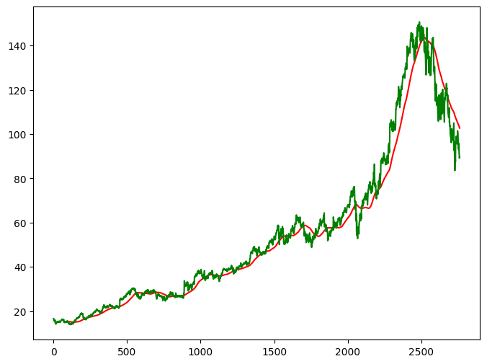

**ma_200_days = data.Close.rolling(200).mean()**

**plt.figure(figsize=(8,6))**

**plt.plot(ma_100_days, 'r')**

**plt.plot(ma_200_days,'b')**

**plt.plot(data.Close,'g')**

**plt.show()**

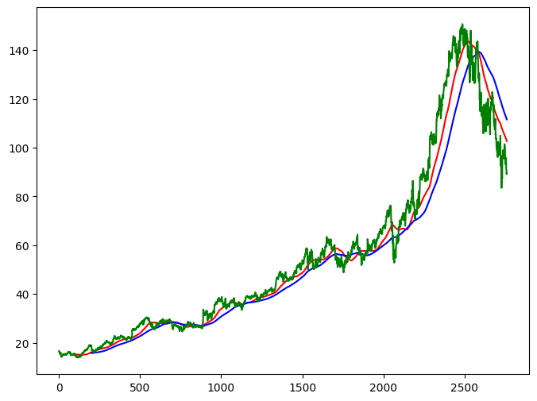

**data.dropna(inplace=True)**

**data_train = pd.DataFrame(data.Close[0: int(len(data)*0.80)])**

**data_test = pd.DataFrame(data.Close[int(len(data)*0.80): len(data)])**

**data_train.shape[0]**

**data_test.shape[0]**

**rom sklearn.preprocessing import MinMaxScaler**

**scaler = MinMaxScaler(feature_range=(0,1))**

**data_train_scale = scaler.fit_transform(data_train)**

**x = []**

**y = []**

**for i in range(100, data_train_scale.shape[0]):**

**x.append(data_train_scale[i-100:i])**

**y.append(data_train_scale[i,0])**

**x, y = np.array(x), np.array(y)**

**from keras.layers import Dense, Dropout, LSTM**

**from keras.models import Sequential**

**model = Sequential()**

**model.add(LSTM(units = 50, activation = 'relu', return_sequences = True,**

**input_shape = ((x.shape[1],1))))**

**model.add(Dropout(0.2))**

**model.add(LSTM(units = 60, activation='relu', return_sequences = True))**

**model.add(Dropout(0.3))**

**model.add(LSTM(units = 80, activation = 'relu', return_sequences = True))**

**model.add(Dropout(0.4))**

**model.add(LSTM(units = 120, activation = 'relu'))**

**model.add(Dropout(0.5))**

**model.add(Dense(units =1))**

**model.compile(optimizer = 'adam', loss = 'mean_squared_error')**

**odel.fit(x,y, epochs = 50, batch_size =32, verbose =1)**

**model.summary()**

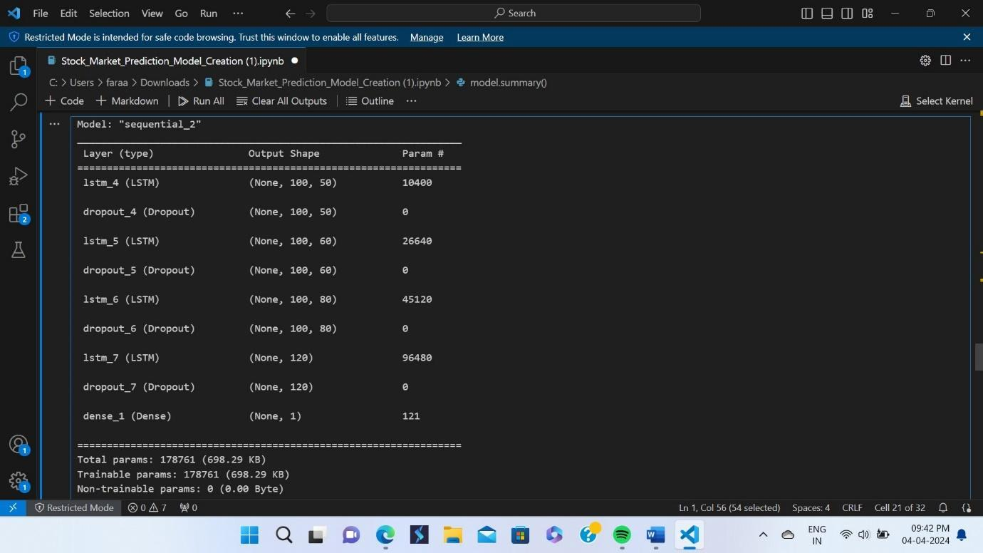

**pas_100_days = data_train.tail(100)**

**data_test = pd.concat([pas_100_days, data_test], ignore_index=True)**

**data_test_scale = scaler.fit_transform(data_test)**

**x = []**

**y = []**

**for i in range(100, data_test_scale.shape[0]):**

**x.append(data_test_scale[i-100:i])**

**y.append(data_test_scale[i,0])**

**x, y = np.array(x), np.array(y)**

**y_predict = model.predict(x)**

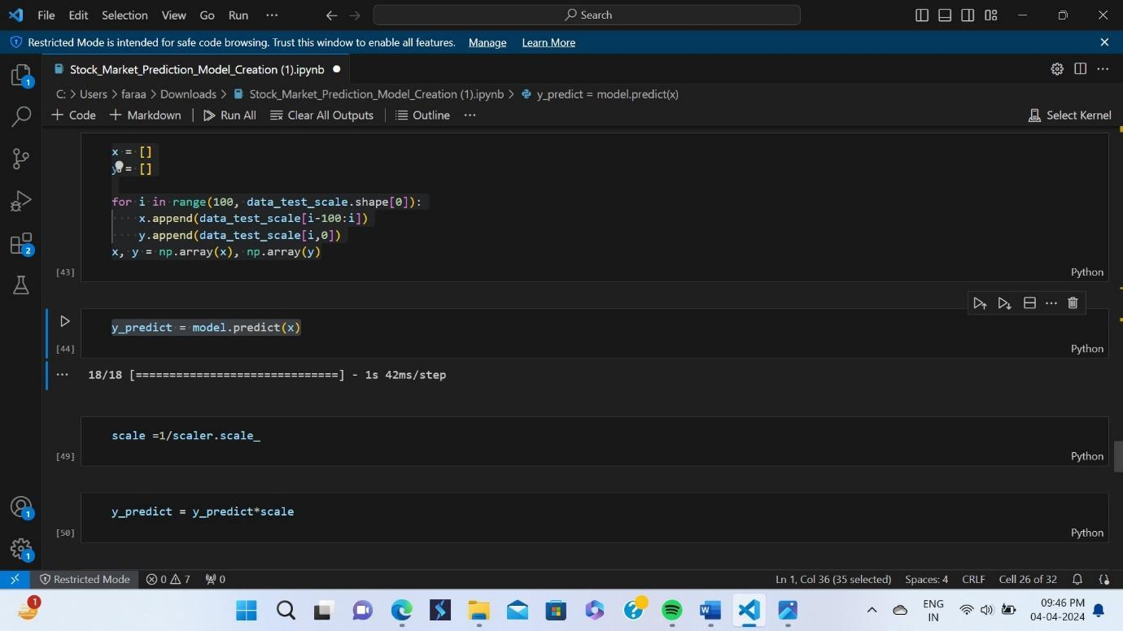

**Scale =1/scaler.scaler_**

**Y_predict = y_predict*scale**

**y = y*scale**

**plt.figure(figsize=(10,8))**

**plt.plot(y_predict, 'r', label = 'Predicted Price')**

**plt.plot(y, 'g', label = 'Original Price')**

**plt.xlabel('Time')**

**plt.ylabel('Price')**

**plt.legend()**

**plt.show()**

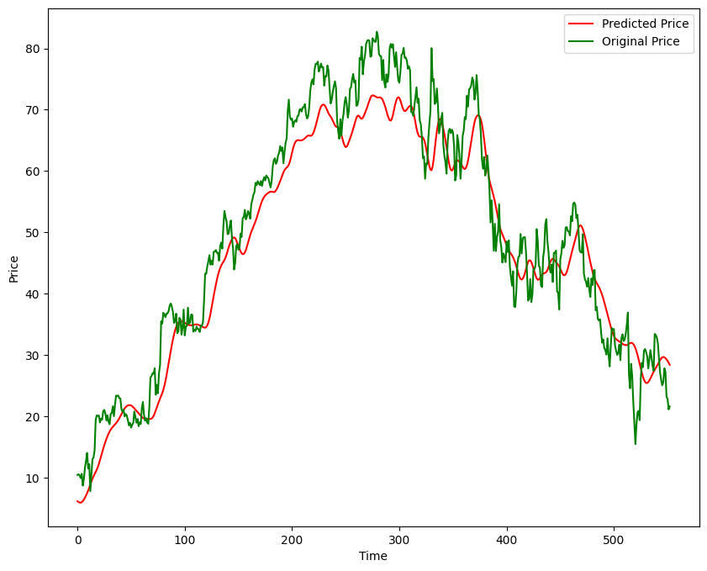

**model.save('Stock Predictions Model.keras')**

# chapter 12

**Different Stocks Analysis and Report**

**Google:**

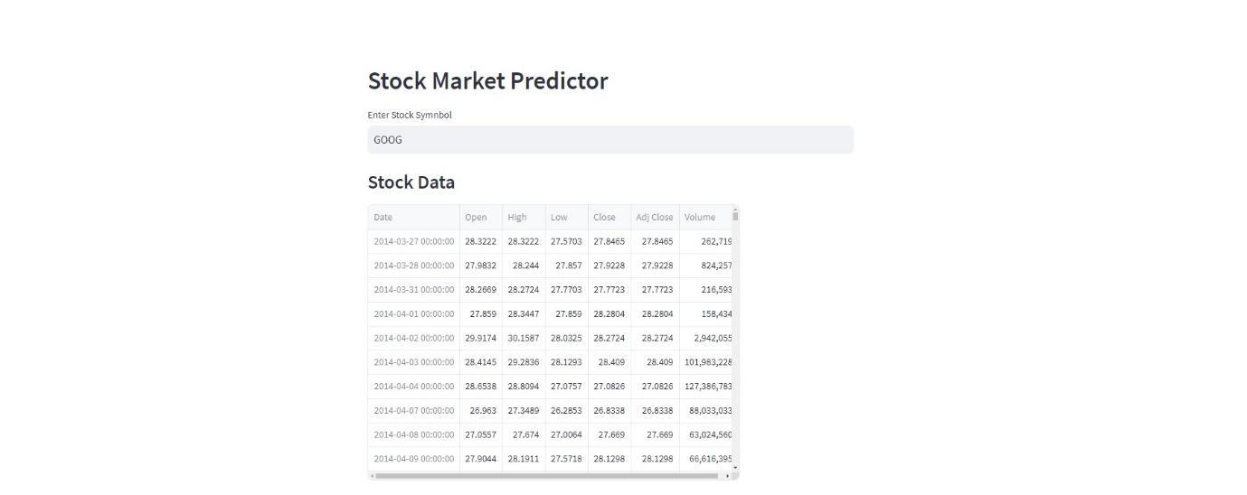

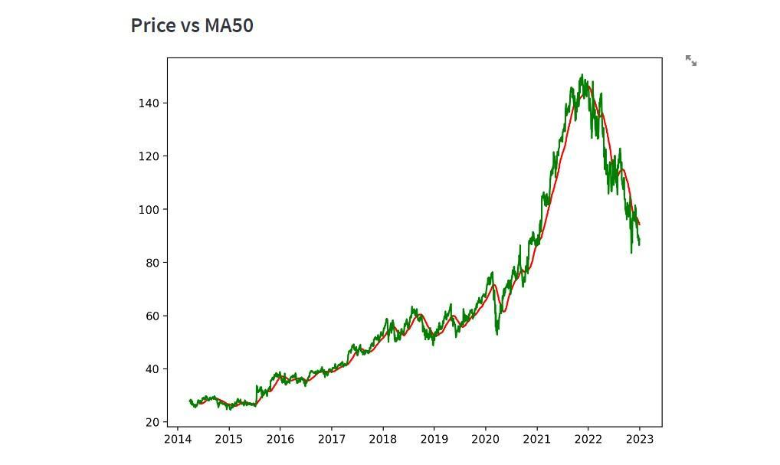

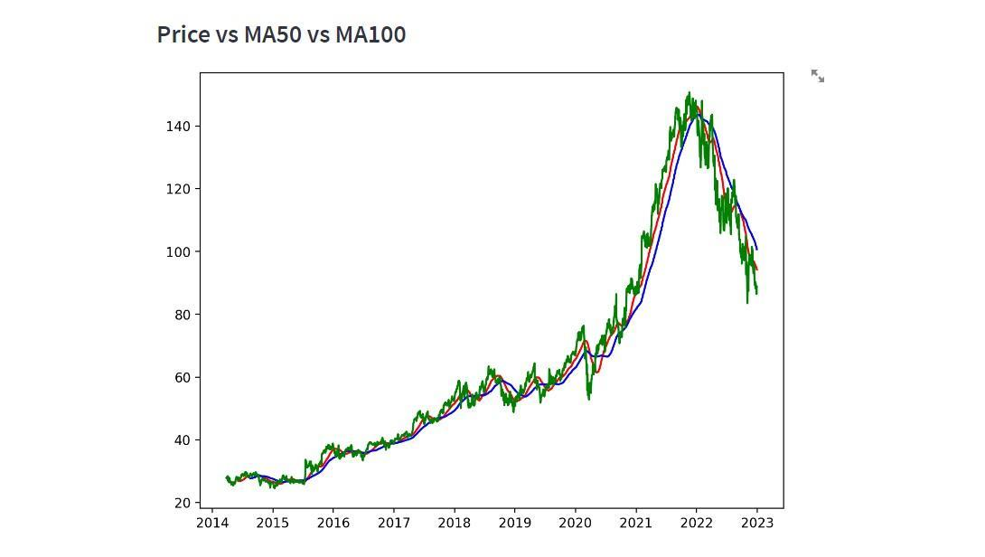

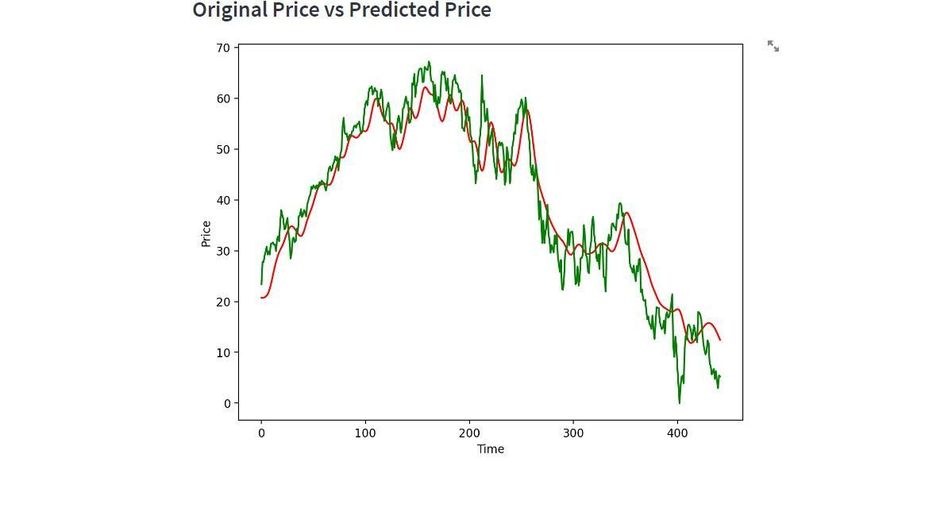

TSLA:

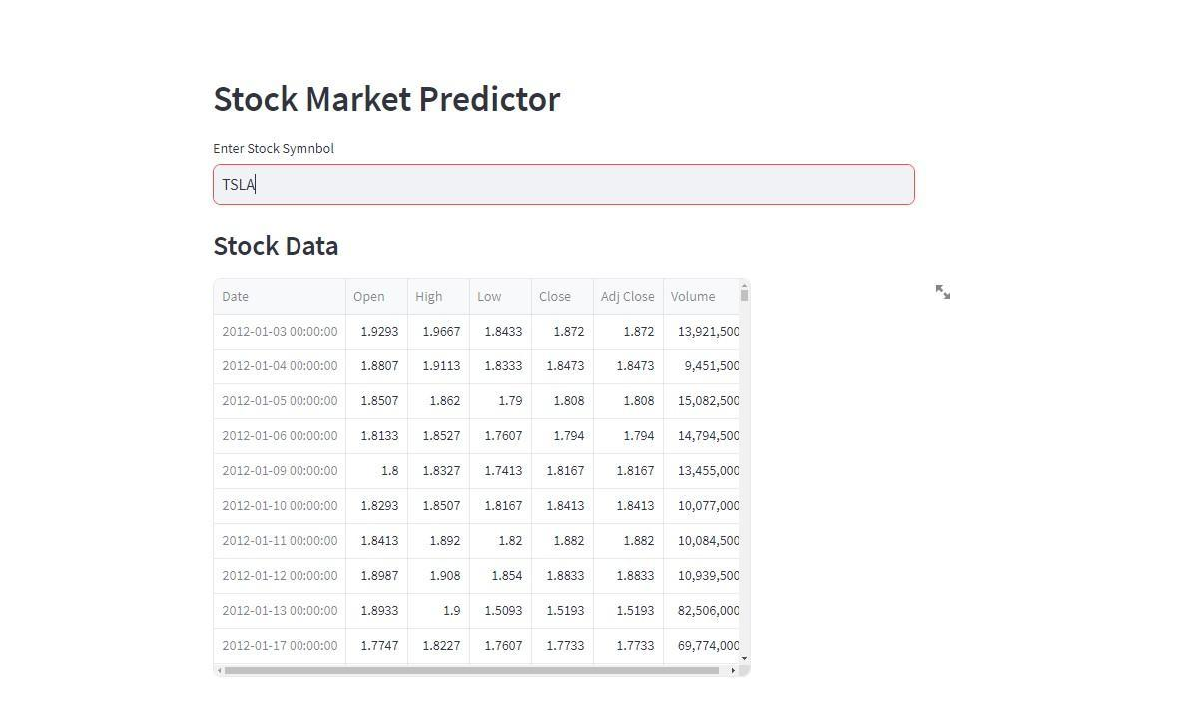

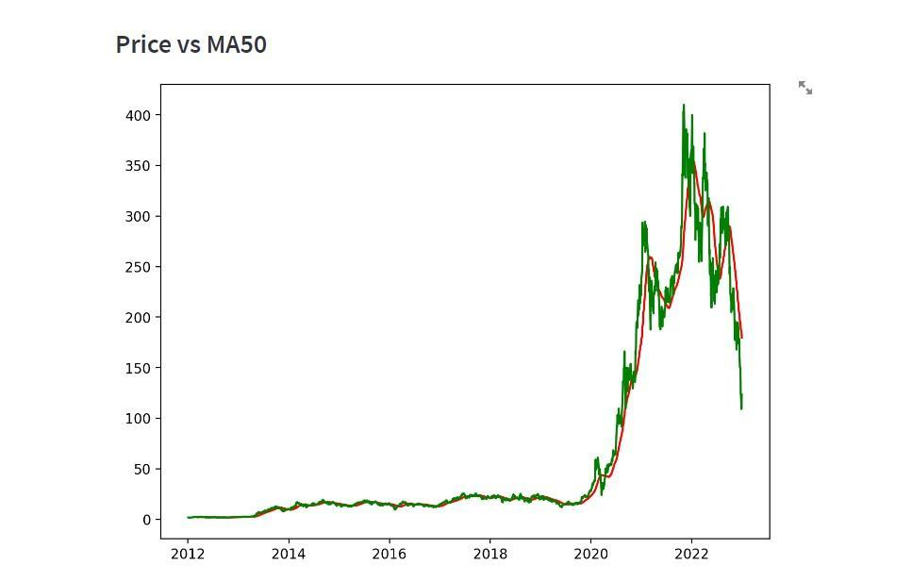

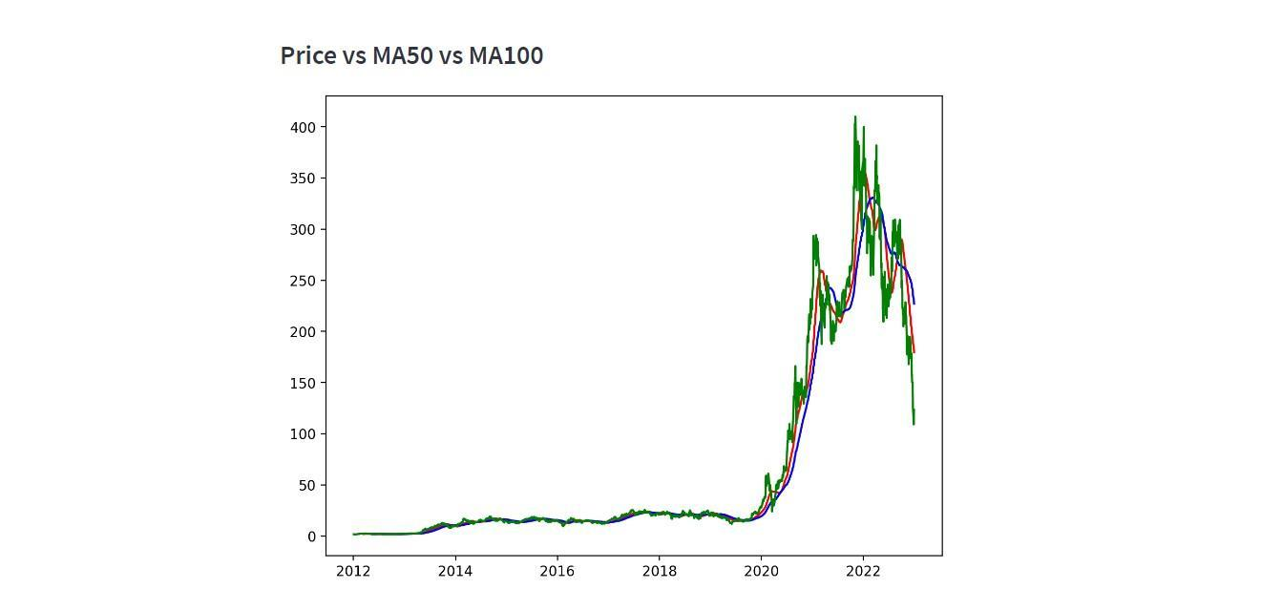

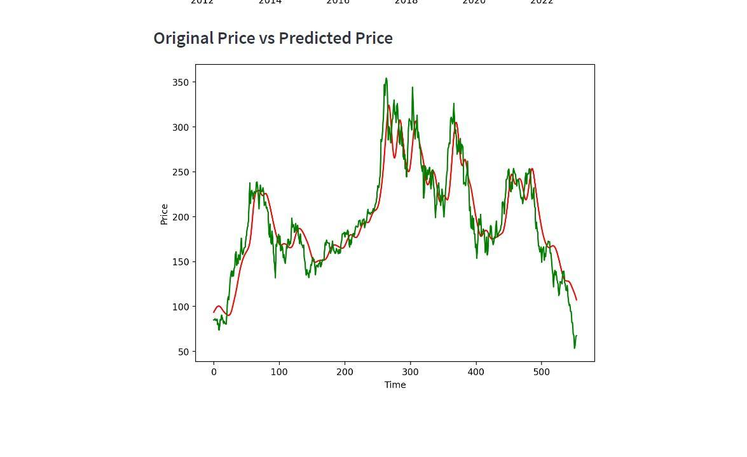

TCS:

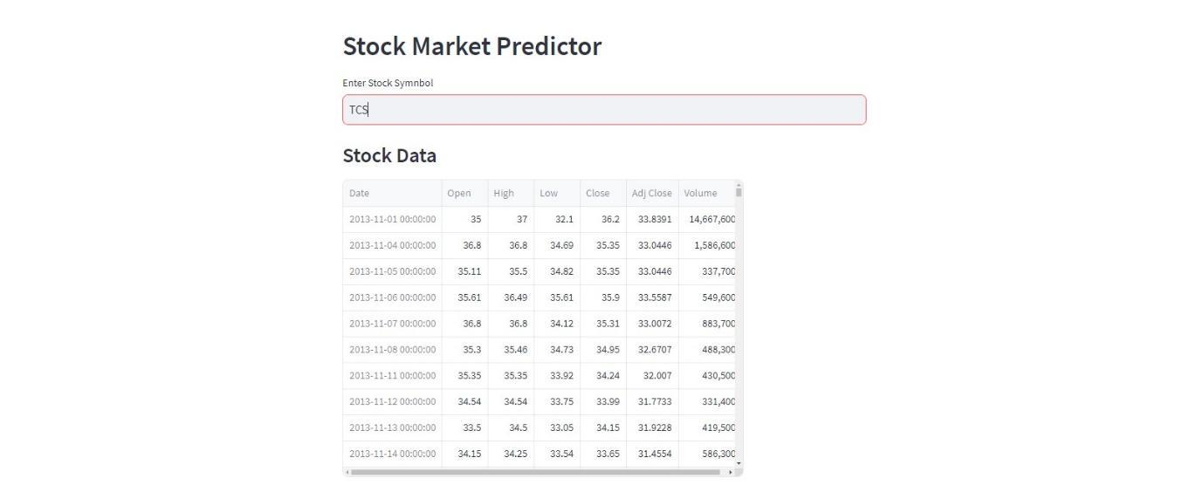

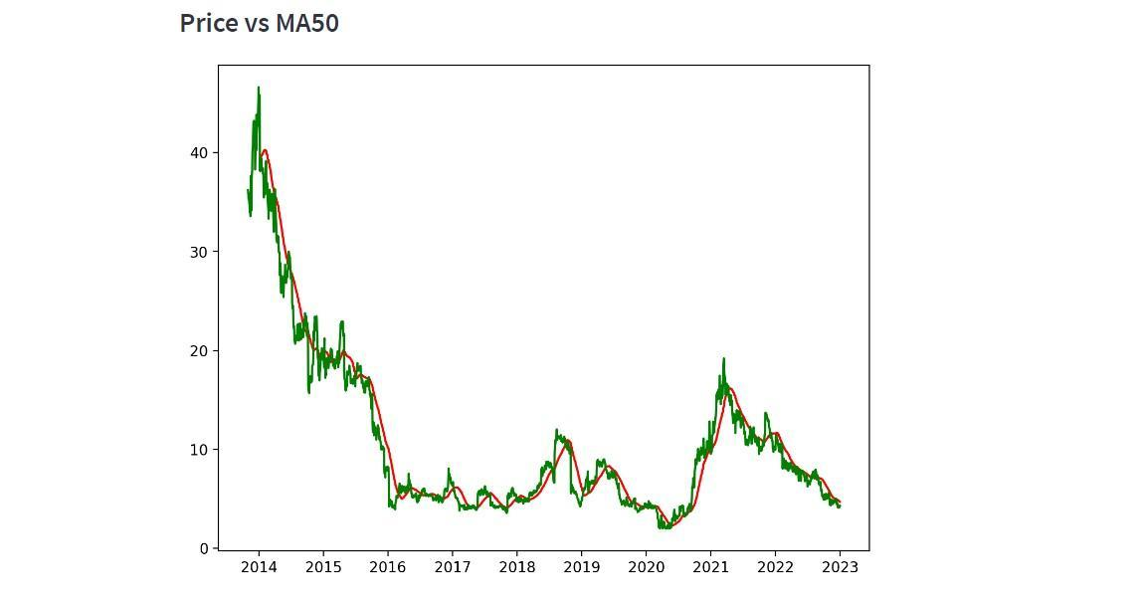

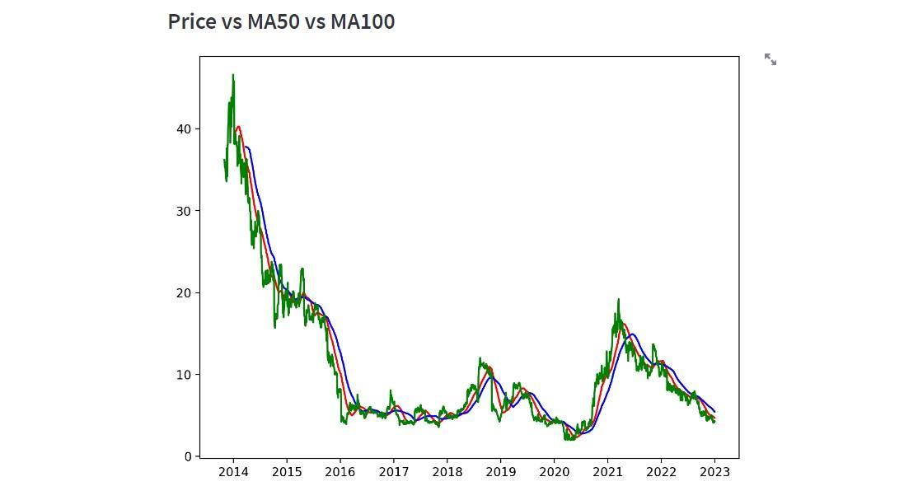

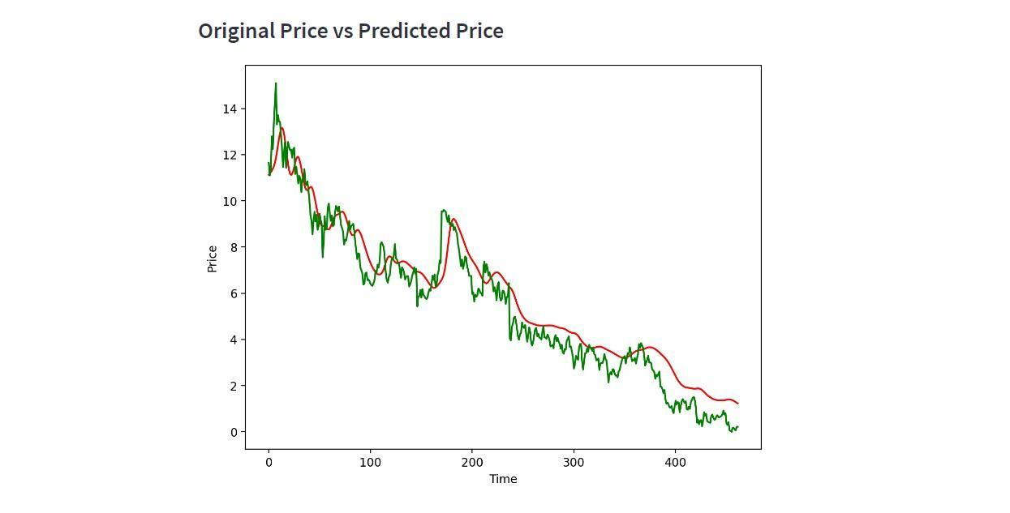

GOLD:

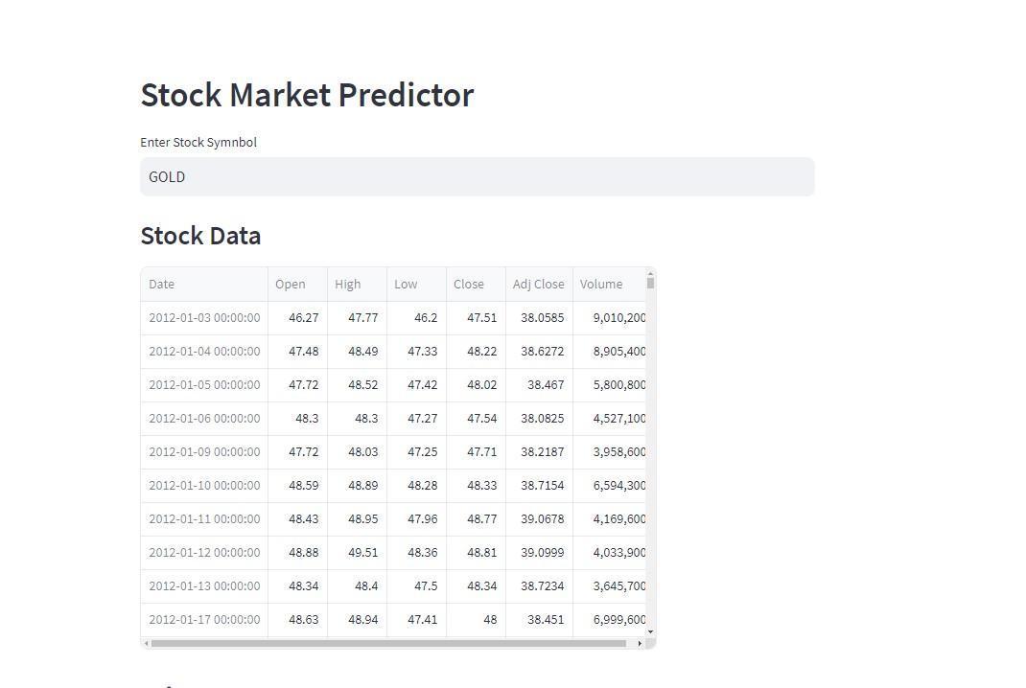

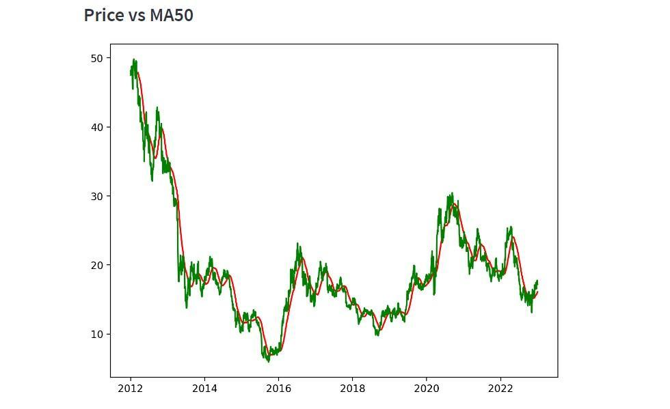

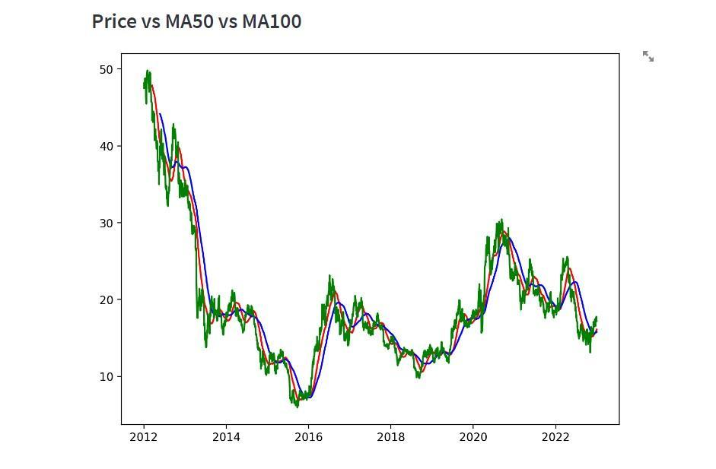

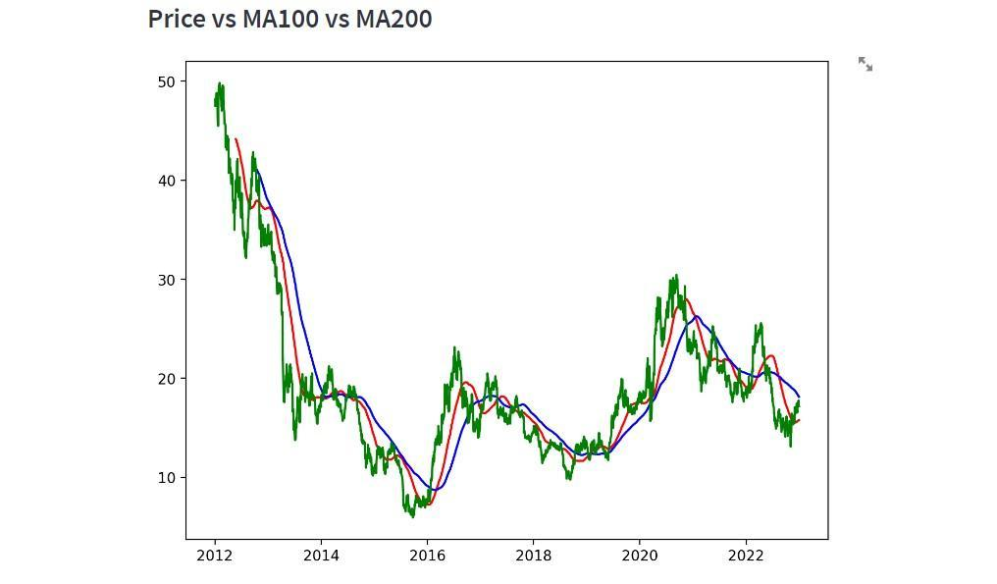

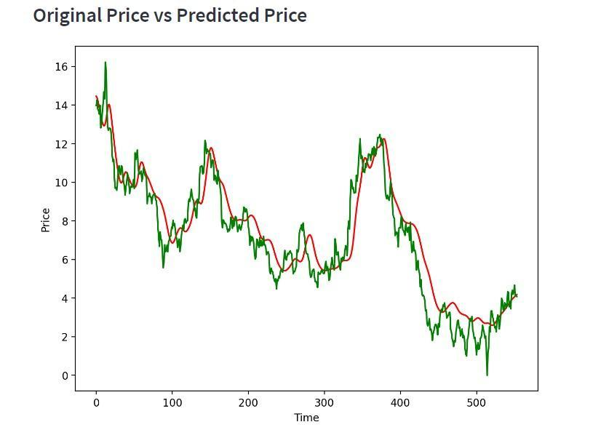

LIFE INSURANCE: 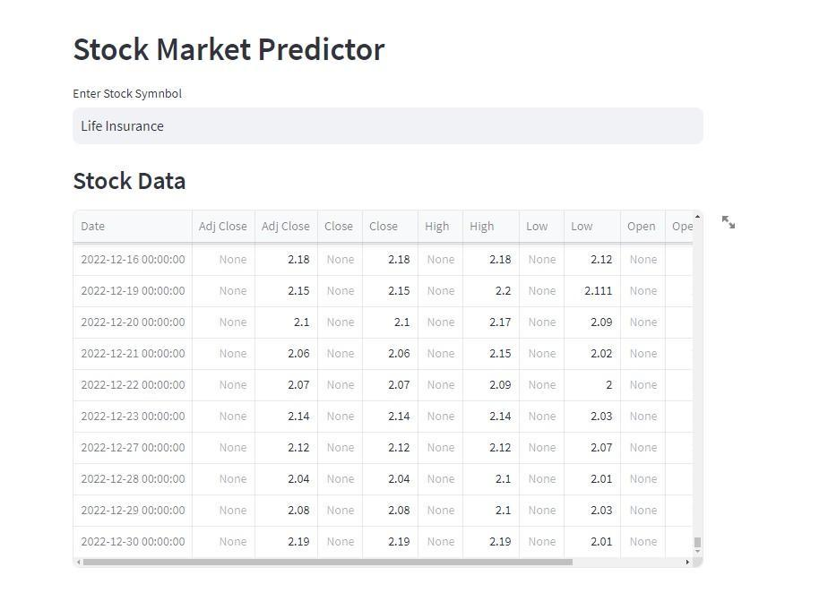

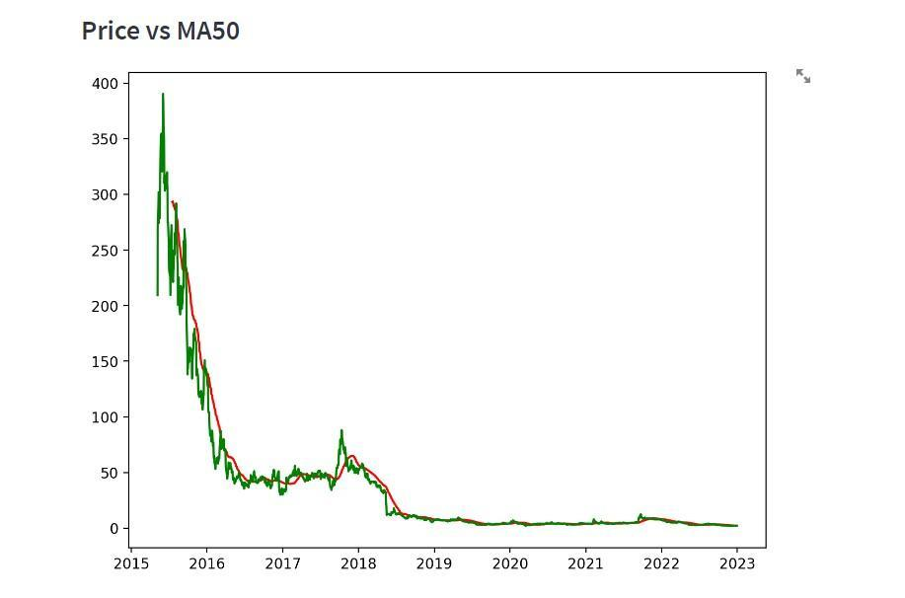

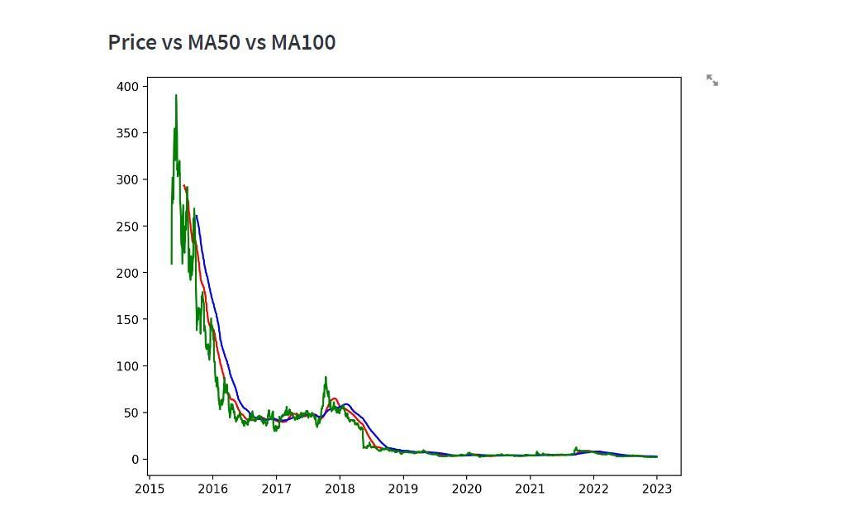

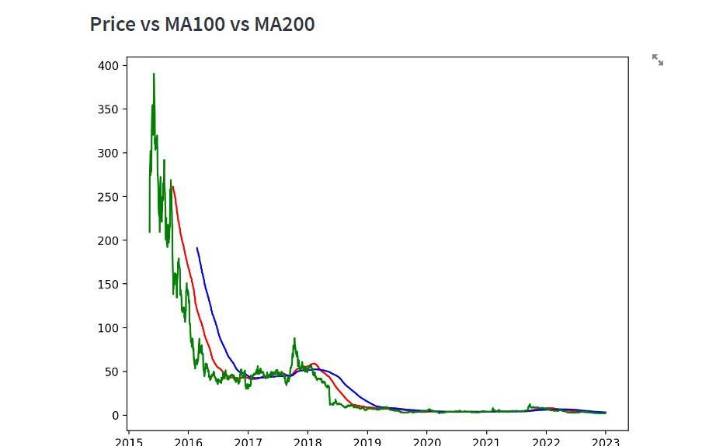

P&G HYGIENE: 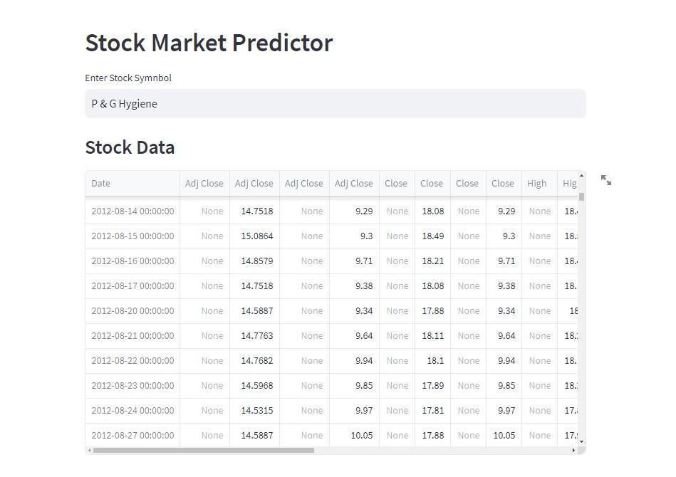

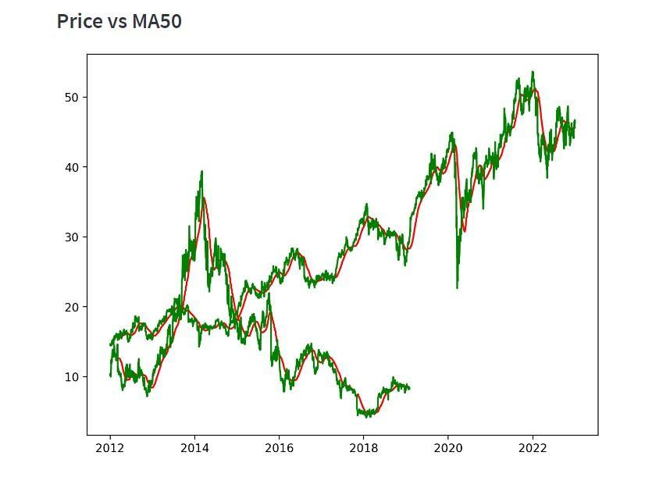

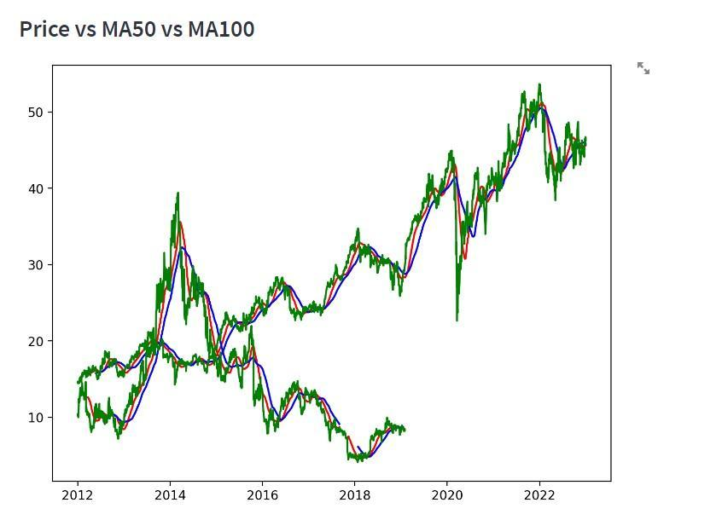

Chapter 13

**Conclusion**

**In this final chapter, we reflect on the journey of developing the Stock Market Prediction System and summarize the key findings, accomplishments, and implications of the project. We also discuss future directions and potential areas for further research and improvement.**

**13.1 Summary of Achievements:**

- Throughout the project, we successfully developed a comprehensive Stock Market Prediction System capable of forecasting stock prices using advanced machine learning techniques. We implemented data collection, preprocessing, model development, visualization, and web application integration components, culminating in a cohesive and user-friendly platform for stock market analysis.

**13.2 Key Findings and Insights:**

- Our exploration and analysis of historical stock market data revealed valuable insights into market trends, patterns, and dynamics. We observed the effectiveness of deep learning models, such as Long Short-Term Memory (LSTM) networks, in capturing temporal dependencies and making accurate predictions, contributing to our understanding of stock market behavior.

**13.3 Implications and Applications:**

- The Stock Market Prediction System has significant implications for various stakeholders, including investors, financial analysts, and decision-makers. By providing timely and accurate forecasts of stock prices, the system empowers users to make informed investment decisions, mitigate risks, and optimize portfolio performance.

**13.4 Limitations and Challenges:**

- Despite the system's strengths, we acknowledge certain limitations and challenges encountered during its development. These include data quality issues, model complexity, computational resource requirements, and the inherent uncertainty and volatility of financial markets. Addressing these challenges will be essential for enhancing the system's reliability and robustness.

**13.5 Future Directions:**

- Looking ahead, there are several avenues for future research and improvement of the Stock Market Prediction System. This includes exploring ensemble learning techniques, incorporating alternative data sources (e.g., news sentiment, social media activity), refining model architectures, and enhancing user interactivity and personalization features in the web application.

**13.6 Conclusion:**

- In conclusion, the Stock Market Prediction System represents a significant achievement in leveraging machine learning and data science techniques to address the complex challenges of stock market forecasting. By combining cutting-edge algorithms, comprehensive data analysis, and intuitive visualization, the system provides a valuable tool for navigating the dynamic landscape of financial markets and empowering users to make informed decisions in an increasingly interconnected and volatile world.

**13.7 Acknowledgments:**

- We extend our gratitude to all individuals, organizations, and resources that contributed to the successful completion of this project. Their support, guidance, and expertise were instrumental in shaping the development and outcomes of the Stock Market Prediction System.

**13.8 References:**

- Lastly, we provide a list of references and resources consulted during the project, including research papers, documentation, tutorials, and open-source libraries. These sources served as valuable sources of knowledge and inspiration throughout the project lifecycle.

---

**This concluding chapter summarizes the accomplishments, insights, implications, and future directions of the Stock Market Prediction System, providing a comprehensive overview of its development and significance in the realm of financial forecasting and decision-making. As we conclude this journey, we look forward to continued exploration, innovation, and advancement in the field of machine learning and finance.**